# **PRACTICAL NO : 1**

**Aim: Perform the REPL in Node.js**

To perform the REPL (Read-Eval-Print Loop) in Node.js

1. Open Command Prompt

b)Write command ‘node’:To launch the Node.js REPL , where you can write Javascript code and execute it interactively.

c) Use the REPL by typing JS expressions or functions.

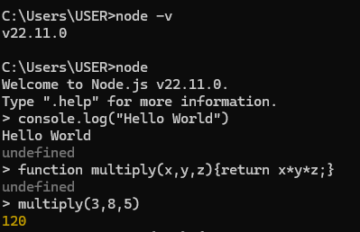

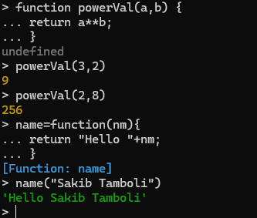

# **PRACTICAL NO : 2**

# **Aim: Using modules, perform the Arithmetic Operations**

**CODE:**

function sum(a,b) {

return a+b;

}

function sub(a,b) {

return a-b;

}

function mul(a,b) {

return a*b;

}

function div(a,b) {

return a/b;

}

console.log("Addition",sum(3,7));

console.log("Subtraction",sub(9,3));

console.log("Multiplication",mul(3,7));

console.log("Division",div(6,2));

**OUTPUT:**

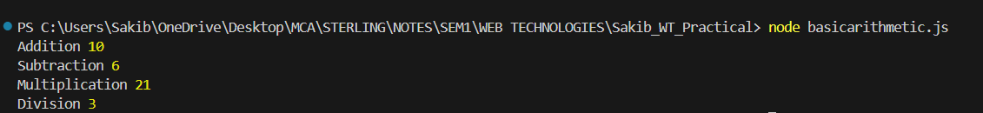

# **PRACTICAL NO : 3**

# **Aim: Using modules, find the Area of a Circle, Rectangle, Square**

**CODE:**

**area.js**

function circleArea(r){

return 3.142*(r**2);

}

exports.circleArea=circleArea;

function squareArea(s){

return s**2;

}

exports.squareArea=squareArea;

function recArea(l,b){

return l*b;

}

exports.recArea=recArea;

**demo.js**

var req1 = require("./area");

console.log("Area of a circle is "+req1.circleArea(2));

console.log("Area of a square is "+req1.squareArea(5));

console.log("Area of a rectangle is "+req1.recArea(5,4));

**Output:**



# **PRACTICAL NO : 4**

# **Aim: Write a program to print the Prime Numbers from 1 to 50**

**CODE:**

function primeNum(){

console.log("The prime numbers from 1 to 50\n")

for(i=2; i<=50; i++){

var count=0;

for(j=2; j<=i/2; j++){

if(i%j==0){

count=1;

break;

}

}

if (count==0){

console.log(i);

}

}

}

primeNum();

**OUTPUT:**

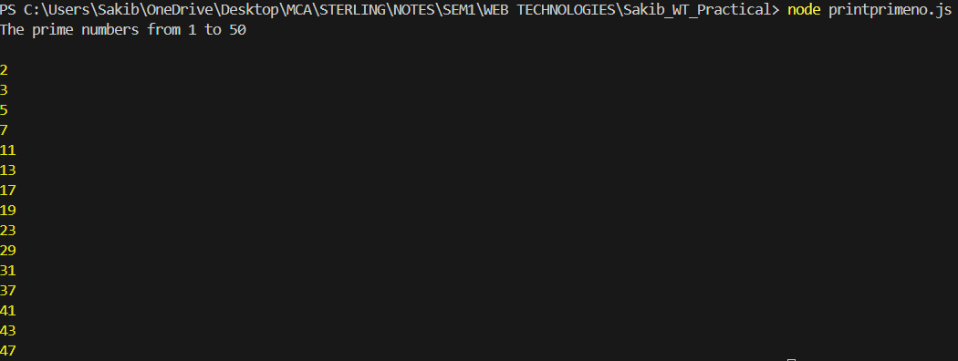

# **PRACTICAL NO : 5**

# **Aim: Write a program to find the reverse of a four-digit number**

**CODE:**

function revNum(a){

var rev=0

var temp=a;

while(a!=0){

r=a%10;

rev=(rev*10)+r;

a=parseInt(a/10);

}

console.log("Reverse of "+temp+" is "+rev);

}

revNum(1234);

revNum(3041602);

**OUTPUT:**



# **PRACTICAL NO : 6**

# **Aim: Write a program to find the number is odd or even**

**CODE:**

function displayresult(a) {

console.log(a);

}

function check(num) {

let sum = num;

if (num % 2 == 0) {

console.log("Number is Even")

}

else {

console.log("Number is Odd ")

}

}

check(18,displayresult)

**OUTPUT:**



# 

# 

**PRACTICAL NO : 7**

**Aim: Write a program to check if the entered number is Armstrong or no**t

**CODE:**

const prompt = require("prompt-sync")();

const num = parseInt(prompt("Enter a number: "));

// Function to check if a number is an Armstrong number

function isArmstrongNumber(num) {

let sum = 0;

const digits = String(num).split(""); // Get an array of digits

const power = digits.length; // Number of digits (power)

for (const digit of digits) {

sum += Math.pow(Number(digit), power); // Add each digit raised to the power

}

return sum === num; // Return true if the sum equals the number

}

// Check if the input number is an Armstrong number

if (isArmstrongNumber(num)) {

console.log(`${num} is an Armstrong number.`);

} else {

console.log(`${num} is not an Armstrong number.`);

}

**OUTPUT:**



**PRACTICAL NO : 8**

**Aim: Write a program to take the marks of four subjects from user and check if the student has passed the examination or not, calculate percentage and grade**

**Code:**

const prompt = require("prompt-sync")();

const mk1 = parseInt(prompt("Enter the marks in ADBMS out of 100 :"))

const mk2 = parseInt(prompt("Enter the marks in Web Technology out of 100 :"))

const mk3 = parseInt(prompt("Enter the marks in Optimized Techniques out of 100 :"))

const mk4 = parseInt(prompt("Enter the marks in Advanced Java out of 100 :"))

const mk5 = parseInt(prompt("Enter the marks in Data Structures out of 100 :"))

if(mk1>=45 && mk2>=45 && mk3>=45 && mk4>=45 && mk5>45){

console.log("You are eligible for the next semester")

const sum = mk1+mk2+mk3+mk4+mk5;

const perc = (sum/500)*100;

console.log(`Your percentage is ${perc}%`);

if (perc >= 80) {

console.log("Grade : A");

}

else if(perc <80 && perc >=60){

console.log("Grade : B");

}

else if(perc <60 && perc >= 35){

console.log("Grade : C")

}

else{

("You have failed the examinations!!!")

console.log("Grade : F")

}

}

**Output:**

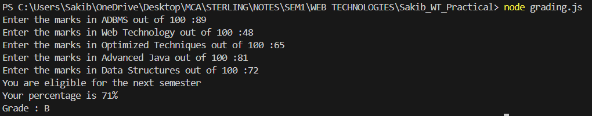

# 

# 

# **PRACTICAL NO : 9**

# **Aim: Write a program to print the Fibonacci series.**

**CODE:**

var a=0;

var b=1;

var c;

console.log(a);

console.log(b);

for(i=0;i<8;i++)

{

c=a+b;

console.log(c);

a=b;

b=c;

}

**OUTPUT:**

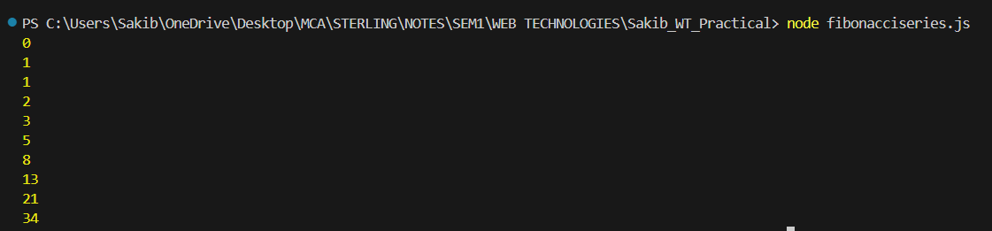

# **PRACTICAL NO : 10**

**Aim: Write a program to convert the temperature entered by the user**.

**CODE:**

const prompt = require('prompt-sync')();

function celsiustofarenheit(celsius){

let farenheit = (celsius* 9/5) + 32;

return farenheit;

}

let celsius = prompt("Enter the temperature into celsius :");

celsius = parseFloat(celsius);

if(!isNaN(celsius))

{

let farenheit = celsiustofarenheit(celsius);

console.log(celsius + "celsius is equal to" + farenheit + "F");

}else{

console.log("Please enter a valid number!!!");

}

**OUTPUT:**



# **PRACTICAL NO : 11**

# **Aim: Write a program to demonstrate the factorial of a number using Anonymous Functions**

**CODE:**

const factorial= (num) =>

{

if (num < 0) {

console.log('Error! Factorial for negative number does not exist.');

}

// if number is 0

else if (num === 0) {

console.log(`The factorial of ${num} is 1.`);

}

// if number is positive

else {

let fact = 1;

for (i = 1; i <= num; i++) {

fact *= i;

}

console.log(`The factorial of ${num} is ${fact}.`);

}

}

factorial(7);

**Output :**



# **PRACTICAL NO : 12**

# **Aim: Write a program to demonstrate the Pattern using Anonymous Functions**

**CODE:**

const pattern =function(num)

{

let string = "";

for (let i = 1; i <= num; i++) {

// printing spaces

for (let j = 0; j < num - i; j++) {

string += " ";

}

// printing star

for (let k = 0; k < i; k++) {

string += "*";

}

string += "\n";

}

console.log(string);

}

pattern(8);

**OUTPUT:**

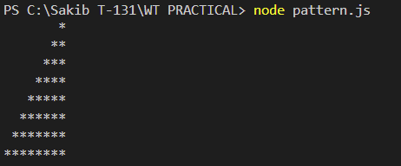

# **PRACTICAL NO : 13**

**Aim: Write a program to demonstrate the arithmetic operations using Callback Functions.**

**Code:**

// Addition

function add(a, b, callback) {

const result = a + b;

callback(result);

}

// Subtraction

function subtract(a, b, callback) {

const result = a - b;

callback(result);

}

// Multiplication

function multiply(a, b, callback) {

const result = a * b;

callback(result);

}

// Division

function divide(a, b, callback) {

if (b !== 0) {

const result = a / b;

callback(result);

} else {

callback('Error: Division by zero');

}

}

// Callback function to display results

function displayResult(result) {

console.log('Result:', result);

}

// Demonstrating arithmetic operations with callbacks

console.log("Arithmetic Operations using Callback Functions in Node.js:");

add(10, 5, displayResult); // 10 + 5 = 15

subtract(10, 5, displayResult); // 10 - 5 = 5

multiply(10, 5, displayResult); // 10 * 5 = 50

divide(10, 5, displayResult); // 10 / 5 = 2

divide(10, 0, displayResult); // Error: Division by zero

**Output :**

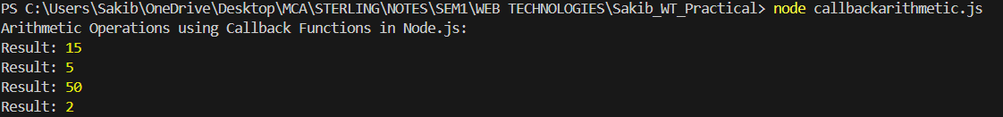

# **PRACTICAL NO : 14**

# **Aim: Write a program to demonstrate setTimeout function.**

**Code:**

const message=function(){

console.log("Hello NodeJS , Welcome");

}

setTimeout(message,5000);

setTimeout(()=> {

console.log("Calling from Arrow Function");

},8000);

**Output:**



# 

# 

# **PRACTICAL NO : 15**

**Aim: Write a program to place the order for a pizza using EventEmitter.**

**Code:**

const EventEmitter=require("node:events")

const emitter1= new EventEmitter();

emitter1.on("order-pizza", (size, topping) =>{

console.log(`Order received ! Baking a ${size} pizza with ${topping} `);

});

emitter1.on("order-no", (no, status) =>{

console.log(`Order ${no} is ${status} `);

});

emitter1.emit("order-pizza","large","mushrooms");

emitter1.emit("order-no","303","Prepared");

**Output :**



# 

# **PRACTICAL NO : 16**

**Aim: Write a program to demonstrate EventEmitter functions.**

**Code:**

const events= require("events");

const eventEmitter= new

events.EventEmitter();

function listner1() {

console.log("Event received by listner 1");

}

function listner2() {

console.log("Event received by listner 2");

}

eventEmitter.addListener("Write", listner1);

eventEmitter.on("Write", listner2);

eventEmitter.emit("Write");

console.log(eventEmitter.listenerCount("Write"));

eventEmitter.removeListener("Write", listner1);

console.log("Listner 1 is removed");

eventEmitter.emit("Write");

console.log(eventEmitter.listenerCount("Write"));

console.log("program ended")

**Output:**

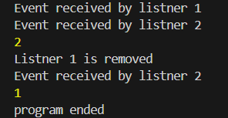

# **PRACTICAL NO : 17**

# **Aim: Write a program to calculate the salary using EventEmitter class**

**CODE:**

const EventEmitter = require('events');

class SalaryCalculator extends EventEmitter {

calculateSalary(basic,ta) {

const hra=0.2*basic; //HRA is 20% of basic

const da= basic; // DA is 100% of basic

const incometax=0.3* basic; //Income tax is 30% of Basic

const professionaltax=200; //Professional tax is 200

const salary= basic+hra+da+ta -incometax- professionaltax;

this.emit('calculateSalary', salary);

}

}

const salaryCalculator = new SalaryCalculator();

salaryCalculator.on('calculateSalary',(salary) => {

console.log(`The calculated salary is : ${salary}`);

});

salaryCalculator.calculateSalary(50000,8000); //Basic Salary is 5000 and TA IS 80000

**OUTPUT:**



**PRACTICAL NO : 18**

**Aim : Write a program to create an EventEmitter to print the sum of odd and even numbers from an array.**

**Code:**

const EventEmitter = require('events');

class OddEven extends EventEmitter {

calculate(arr) {

let oddSum = 0;

let evenSum = 0;

// Loop through the entire array

for (let i = 0; i < arr.length; i++) {

if (arr[i] % 2 === 0) {

evenSum += arr[i]; // Add to even sum

} else {

oddSum += arr[i]; // Add to odd sum

} }

// Emit the 'calculate' event with results

this.emit('calculate', oddSum, evenSum);

}

}

// Create an instance of the OddEven class

const oddevenInstance = new OddEven();

// Set up the 'calculate' event listener

oddevenInstance.on('calculate', (oddSum, evenSum) => {

console.log(`The sum of odd numbers is: ${oddSum}`);

console.log(`The sum of even numbers is: ${evenSum}`);

});

// Call the calculate method with a sample array

oddevenInstance.calculate([2, 3, 4, 5]);

**Output :**



# **PRACTICAL NO : 19**

**Aim : Write a program to demonstrate File handling in Node.js**

**CODE:**

const fs=require("fs");

fs.writeFile("com.txt","Hello World", function(err,data)

{

console.log("Writing File");

});

fs.appendFile("_com.txt","\n Hello Everyone \n Give ThumbsUp", function

(err,data)

{

console.log("Append File");

});

fs.readFile("_com.txt","utf-8",function(err,data)

{

console.log("Reading File");

console.log(data);

});

fs.unlink("_com.txt",function(err,data)

{

console.log("Deleting File");

console.log("File Deleted");

});

const fd=fs.openSync("com.txt","r+");

const text="Janet Doe";

const position=0;

const numberOfBytesWritten=fs.writeSync(fd ,text,position,"utf8");

console.log(`Bytes written :${numberOfBytesWritten}`);

**OUTPUT:**

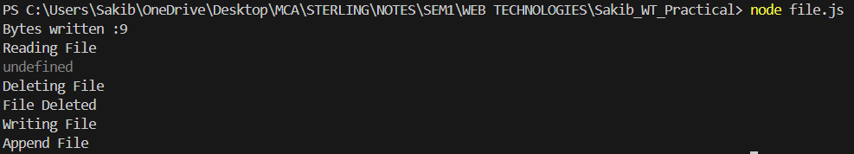

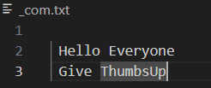

# 

# 

# 

# **PRACTICAL NO : 20**

# **Aim : Write a Node.js code to display Employee Job Registration form saved in html file in response to the client’s access request to server.**

**Code:**

**form.js**

const http=require("http");

const fs=require("fs");

http.createServer((req,res)=> {fs.readFile('register.html',(err,data) => {

if(data){

res.writeHead(200,{'Content-Type':'text/html'});

res.end(data);

}

});

}).listen(8000,()=> {

console.log("Server is running at http://localhost:8000");

});

**Register.html**

<html>

<head>

<title>Employee Registration Form</title>

</head>

<body bgcolor="#fba650" text="white" style="font-family: 'Gill Sans', 'Gill Sans MT', Calibri, 'Trebuchet MS', sans-serif;">

<h1 style="text-align: center;"> Employee Registration Form</h1>

<form>

Employee Name :<input type="text"/> <br> <br>

Employee Id :<input type="number"/> <br> <br>

Salary :<input type="number"/> <br><br>

Location: <input type="text"/> <br><br>

<input type="submit" style="border-radius: 2cm;"/>

</form>

</body>

</html>

**Output:**



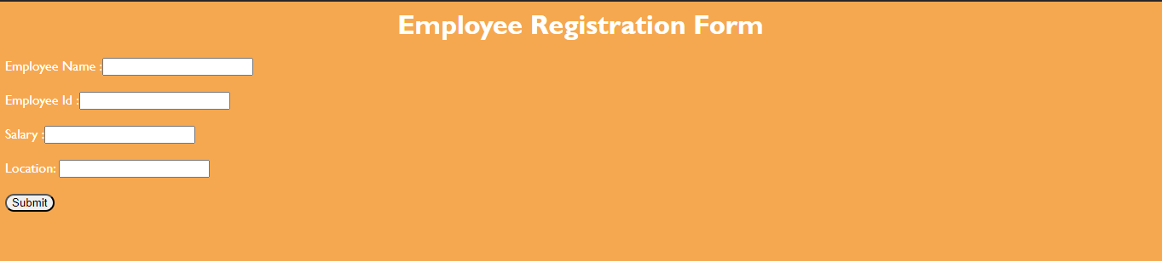

# 

# 

**PRACTICAL NO : 21**

# **Aim: Write a program to handle request url between various HTML pages using HTTP Server**

**Code:**

**server1.js**

var http = require('http');

//const text = require('stream/consumers');

var server =http.createServer(function(req,res) {

if(req.url=='/'){

res.writeHead(200,{'content-type':'text/html'});

res.write('<html></head><body>');

res.write('<style> ul li{display: inline-block; float: right; height: 40px;} ul li a{padding: 20px; background:orange; color: white;}</style>');

res.write('<div><h1>First WebPage using http Server</h1></div><div><ul><li><a href="/admin">Contact Admin</a></li><li><a href="/student">Student</a></li><li><a href="/home">Home</a></li></ul></div></div>');

res.write('<div style="background: white; padding: 20px;"><h2>Start Page</h2><p>This is my first webpage!</p><p>Hi everyone</p></div></body></html>');

res.end();

}

else if(req.url=='/home')

{

res.writeHead(200,{'content-type':'text/html'});

res.write('<html><head><style>body{padding-left: 43px; padding-right:43px; background-color:lightyellow;} </style></head><body><p><h1>This is home page</h1></p><h1>Sakib Tamboli</h1><h3>This page is a brief insight to who I am.</h3>');

res.write('<nav style="background-color:white; text- align:center;"><ul><li><a href="/">Start Page</a></li><li><a href="/student">Student</a></li><li><a href="/admin">Admin</a></li></ul></nav></body></html>');

res.end();

}

else if (req.url=='/student')

{

res.writeHead(200,{'content-type':'text/html'});

res.write('<div style="display: inline-block; float: right; height: 40px; padding: 20px;"><ul><li><a href="/home">Home</a></li><li><a href="/">Start Page</a></li> <li><a href="/admin">Contact Admin</a></li></ul></div>');

res.write('<html><head><style>body{background- color:pink;}</style><title>Form</title></head><body bgcolor="White" ><h1 align="center">Student Page Form</h1>');

res.write('<form action="url" method="post"><fieldset><legend>Personal Imformation</legend>');

res.write('<lable><Strong>Student Name</strong></lable><br/><input type="text" name="Student Name" placeholder="Enter Your Name" /><br/>');

res.write('<lable><Strong>Email</strong></lable><br/><input type="email" name="eamil" placeholder="Enter Your Email Address" /></br>');

res.write('<lable><Strong>Password</strong></lable><br/>');

res.write('<input type="password" name="Password" placeholder="Enter Your Password" /></br><lable><Strong>Gender</strong></lable><br/>'); res.write('<input type="Radio" name="Gender" value="Male" />Male<input type="Radio" name="Gender" value="FeMale" />FeMale<br/>'); res.write('<lable><Strong>Hobbies</strong></lable><br/>'); res.write('<input type="checkbox" name="Hobbies" value="Playing Sports" />Playing Sports<br/>');

res.write('<input type="checkbox" name="Hobbies" value="Listening Music" />Listening Music<br/>');

res.write('<input type="checkbox" name="Hobbies" value="Traveling"/>Traveling<br/>');

res.write('<input type="checkbox" name="Hobbies" value="Reading Books"/>Reading Books<br/>');

res.write('<lable><Strong>Select Your City</strong></lable><select name="City">');

res.write('<option value="Mumbai">Mumbai</option><option value="Gujrat">Gujrat</option><option value="Pune">Pune</option>');

res.write(' <option value="Thane">Thane</option></select></br><input type="submit" onclick=alert("Thanks!") name="submit" value="Submit"/></form>');

res.end();

}

else if (req.url=='/admin')

{

res.writeHead(200,{'content-type':'text/html'});

res.write('<style>ul li{display: inline-block; float: right; height:40px;} ul li a{padding: 20px; background:orange; color: white;}</style>'); res.write('<div><ul><li><a href="/admin">Contact Admin</a></li><li><a href="/student">Student</a></li><li><a href="/home">Home</a></li></ul></div></div><br><br>');

res.write('<html><head><style>legend{text-align:center;} body{background-color:faf89a;border: 5px solid darkred;} form{display: inline- block; float: center; padding: 20px;} ');

res.write('border-radius:4px; padding:40px 5px; max- width:100%;}</style></head>');

res.write('<legend><h1><u>Admin Login</u></h1></legend>');

res.write('<form action="#" method="POST" autocomplete="off">');

res.write('<div class="input_field"><h3>Username</h3></div><div class="input_field"><input type="text" ');

res.write('name="userid" placeholder="Username" required/></div>');

res.write('<div class="input_field"><h3>Password</h3></div><div class="input_field"><input type="Password"');

res.write('name="pword" placeholder="Password" required/></div><p>');

res.write('<style>button{border:none; border-radius:5px; text-align:center; padding:15px 15px; background- color:lavender;<div></div></style>');

res.write('<button onclick=alert("SUCESS")>LOGIN NOW</button></form>');

res.end();

}

else{

res.end('Invalid request');

}

});

server.listen(9000);

console.log('Node.js web server at port 9000 is running');

**Output:**

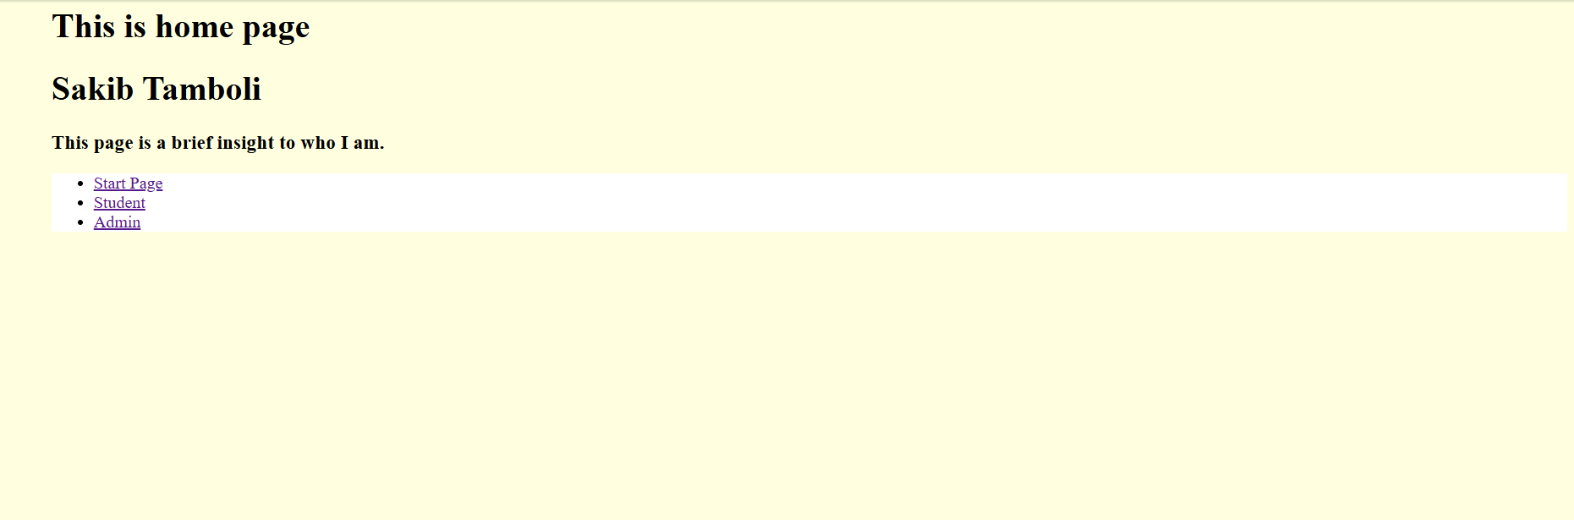

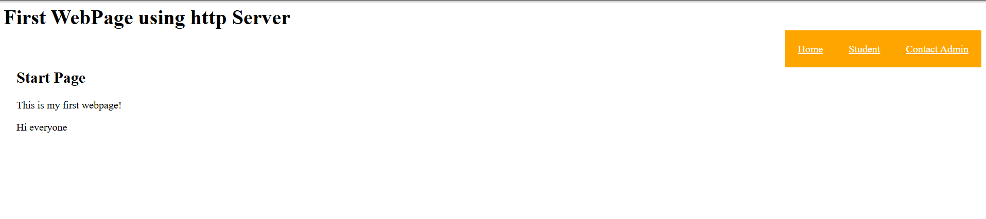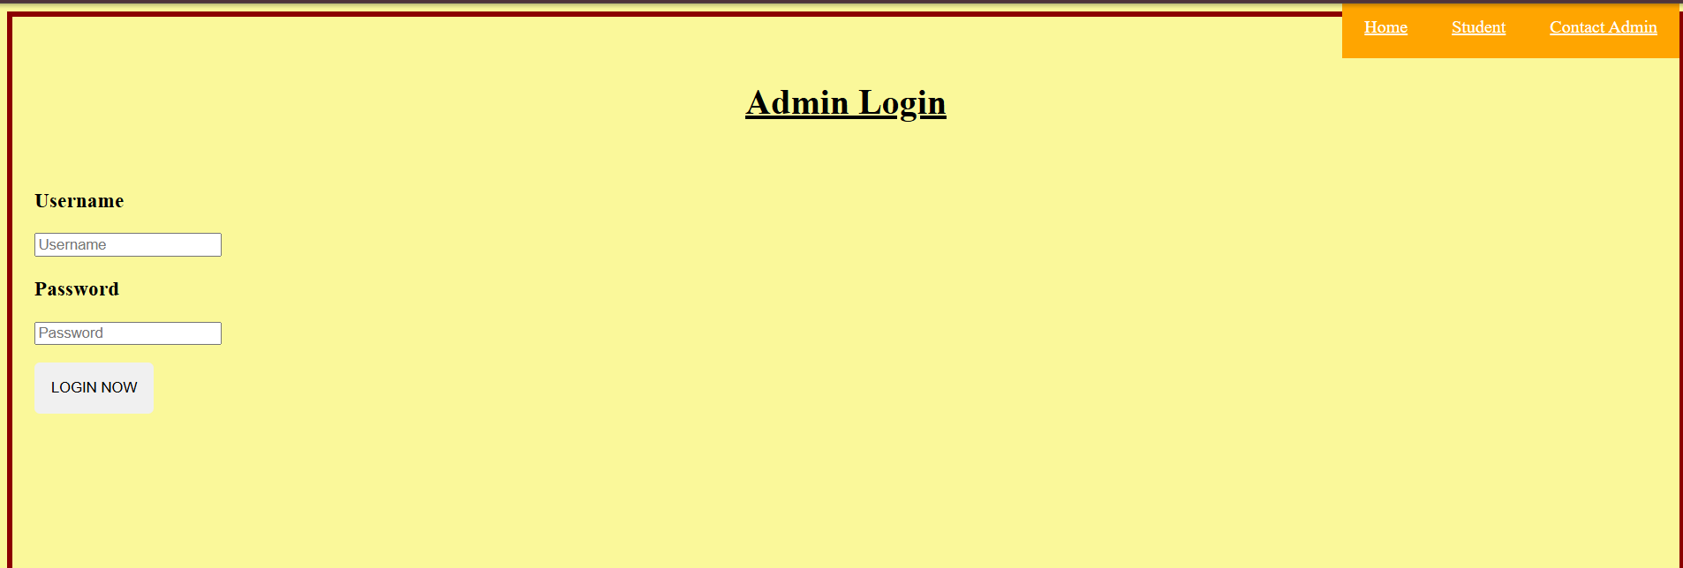

# **PRACTICAL NO : 22**

**Aim: Write a program to implement the database in node.js.**

1. **Create database**

**product_database.js**

var mysql=require('mysql')

var con=mysql.createConnection({

host:"localhost",

port:"3306",

user:"root",

password:"",

});

con.connect(function(err){

if (err) { throw err;}

else{

console.log("Connected");}

con.query("Create Database Product" , function(err,result) {

if (err) throw err;

console.log("Database Created");

});

});

**Output:**



# **b) Create an Application to create product table with columns as Product_id ,Product_name , Product_type,Product_quantity , Price in Node.js**

**product_table.js**

var mysql=require('mysql')

var con=mysql.createConnection({

host:"localhost",

user:"root",

password:"",

database:"product",

});

con.connect(function (err)

{

if(err) throw err;

console.log("connected....");

var sql="CREATE TABLE product_details(Product_id INT(10) PRIMARY KEY AUTO_INCREMENT, Product_name VARCHAR(255) , Product_type VARCHAR(255) , Product_quantity VARCHAR(20), Price INT(15))";

con.query(sql,function (err,result)

{

if(err) throw err;

console.log("table created");

});

});

**OUTPUT :**



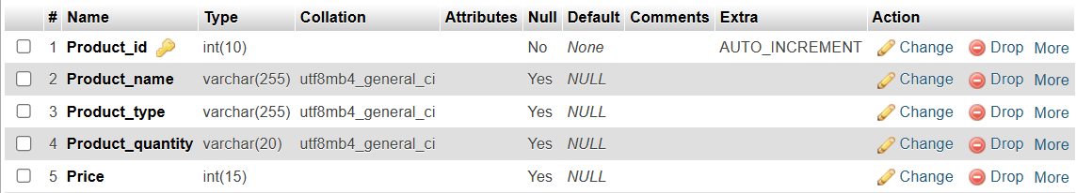

# 

# **c) Create an Application to insert rows into Product table in Node.js**

**product_details.js**

var mysql=require('mysql')

var con=mysql.createConnection({

host:"localhost",

user:"root",

password:"",

database:"Product",

});

con.connect(function(err)

{

if(err) throw err;

console.log("connected...");

var sql2 = "INSERT INTO product_details(Product_id ,Product_name , Product_type,Product_quantity , Price) VALUES('1001','Boat','Headphones','99','2000'),('1002','LG','TV','50','50000'),('1003','SAMSUNG','FRIDGE','82','40000'),('1004','HP','LAPTOP','300','49000'),('1005','FIREBOLT','WATCH','500','1500'),('1006','VOLTAS','AC','20','30000'),('1007','FABER','OVEN','241','5000'),('1008','SONY','SPEAKER','123','8000'),('1009','DELL','MOUSE','65','500'),('1010','WHIRPOOL','WASHING MACHINE','30','18000')";

con.query(sql2,function(err,result)

{

if(err) throw err;

console.log("DATA ADDED");

});

});

**OUTPUT :**



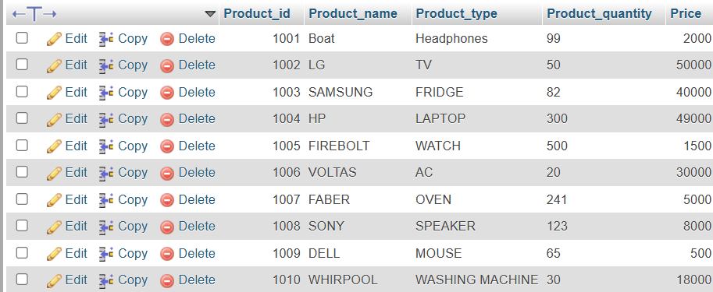

# **d) Create an Application to display rows into Product table in Node.js**

# **product_display.js**

var mysql=require('mysql'); var con=mysql.createConnection (

{

host:'localhost', user:'root', port:3306, database:'product'

}

);

con.connect(function(err) {

if(err) throw err;

console.log("connected...");

var sql2="select * from product_details";

con.query(sql2,function(err,result) {

if(err) throw err;

console.log(result);

});

});

**Output :**

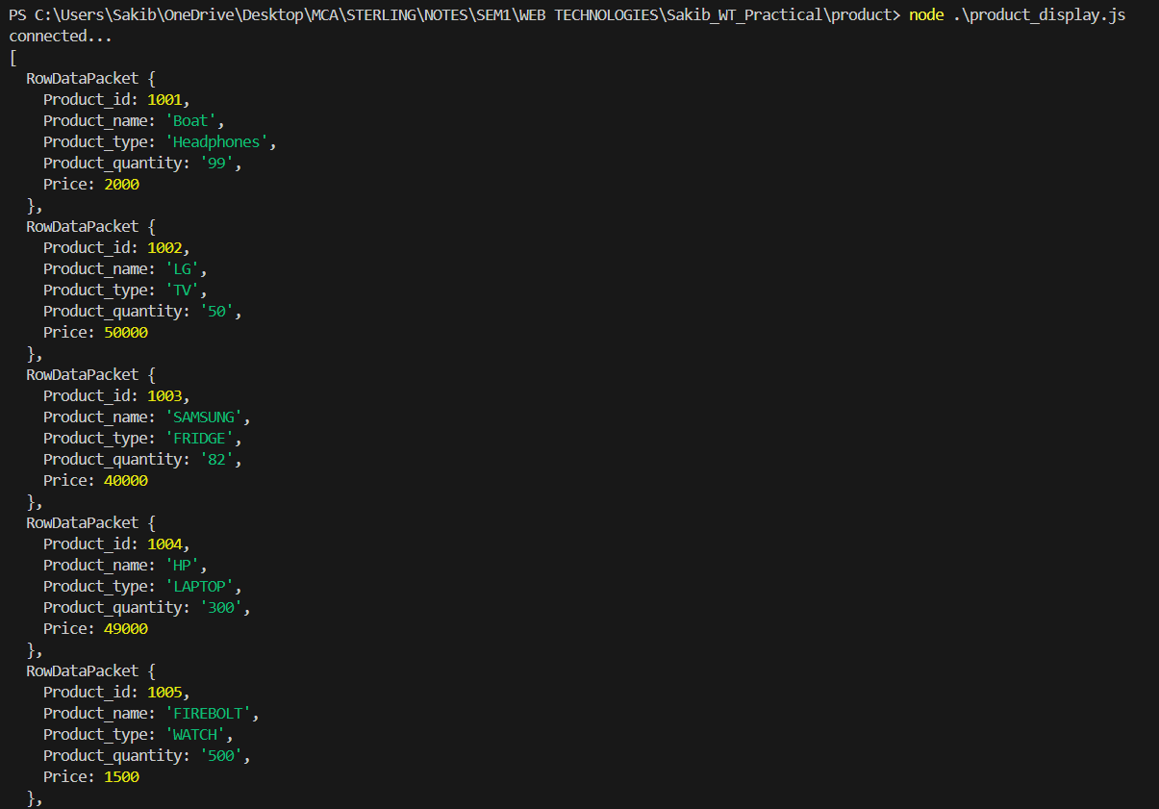

# **e) Write a Node.js application to retrieve and update the product name whose product id is 1004.**

**Product_update.js**

var mysql = require('mysql');

var con = mysql.createConnection({

host: "localhost",

user: "root",

port: 3306,

database:"product"

});

con.connect(function(err) {

if (err) throw err;

console.log("Connected successfully to server");

var sql = "SELECT * FROM product_details WHERE Product_id = '1004'";

con.query(sql, function(err, result) {

if (err) throw err;

console.log("Product found: ", result);

var newNAME = 'ACER';

var updateSql = `UPDATE product_details SET Product_name = '${newNAME}' WHERE Product_id = '1004'`;

con.query(updateSql, function(err, result) { if (err) throw err;

if (err) throw err;

console.log("Number of records updated: " + result.affectedRows);

});

});

});

**OUTPUT:**

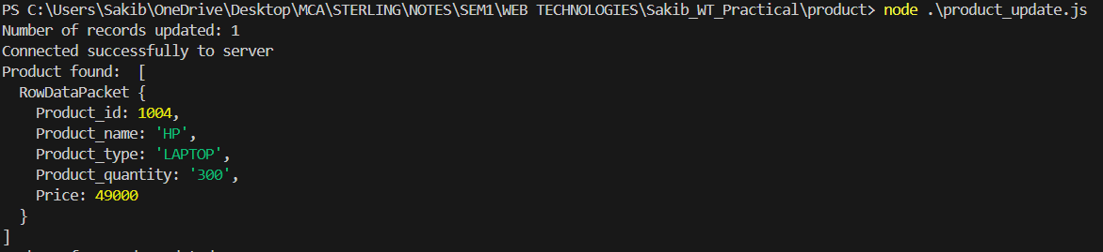

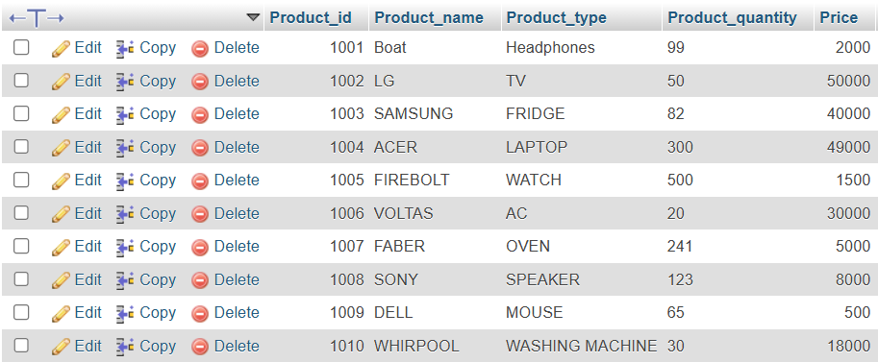

# **f) Create an Application to add column to Product table in Node.js**

**product_add.js**

var mysql=require('mysql')

var con=mysql.createConnection({

host:"localhost",

port:"3306",

user:"root",

password:"",

database:"Product",

});

con.connect(function(err) {

if(err) throw err;

console.log("connected...");

var sql = "ALTER TABLE Product_details ADD Product_status Varchar (25)";

con.query(sql,function(err,result) {

if(err) throw err;

console.log("column inserted successfuly...");

});

});

**OUTPUT:**



